Project Design Phase-II
Technology Stack (Architecture & Stack)

Date | 31 January 3035
Team ID | LTVIP2026TMIDS71321
Project Name | Dog Breed Identification using Transfer Learning
Maximum Marks | 4 Marks

Technical Architecture:
The Deliverable shall include the architectural diagram as below and the information as per the table1 & table 2
Example: Dog Breed Identification using transfer learning
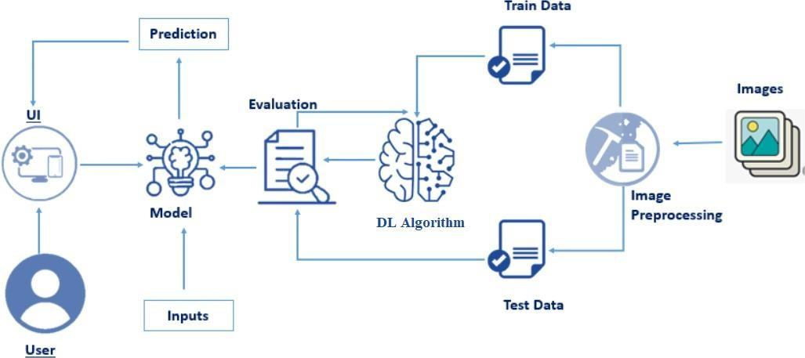

Table-1 : Components & Technologies:
S.No | Component | Description | Technology
 | User Interface | Web interface for image upload and result display | HTML, CSS, JavaScript
 | Application Logic-1 | Handles image upload and preprocessing | Python (Flask)
 | Application Logic-2 | Model integration and prediction logic | TensorFlow / Keras
 | Application Logic-3 | Displays prediction results and breed details | Python (Backend logic)
 | Database | Stores breed information and user data | MY SQL
 | Cloud Database | Cloud-based data storage | Firebase / MongoDB Atlas
 | File Storage | Stores uploaded dog images | Local File System / Cloud Storage
 | External API-1 | (Optional) Fetch additional breed details | Dog Breed API
 | External API-2 |  | Public Pet Care API
  (Optional) Fetch pet care information
 | Machine Learning Model | Image classification for dog breed prediction | Transfer Learning (ResNet50 / VGG16)
 | Infrastructure (Server / Cloud) | Deployment on local or cloud server | Local Server / AWS / Google Cloud

Table-2: Application Characteristics:
S.No | Characteristics | Description | Technology
 | Open-Source Frameworks | Frameworks used for model & web app | TensorFlow, Keras, Flask
 | Security Implementations |  | HTTPS, Password Hashing (SHA-256)
  Data protection and secure access
 | Scalable Architecture | 3-tier architecture (UI, Logic, Database) | Cloud Deployment
 | Availability | System available online with cloud hosting | AWS / Google Cloud
 | Performance | Optimized model for faster prediction | Transfer Learning, Image Preprocessing

